Lab 10: Climate Change
GEOL1551
Name: _____________________________

25th SEPT 2020

Climate Change

Climate is different from weather. Weather is the day to day variation of temperature, precipitation and wind patterns. Climate is the long-term (multi-year) average of those conditions. It’s actually defined as the 30-year average of those conditions by the World Meteorological Organization. So, when we have an unusually cold day in the summer or fall, you can complain about the weather, but it doesn’t necessarily relate to what the climate is doing; you must consider decadal scale average conditions and their trends.

Earth Scientists rely on a myriad of different techniques to understand past, present and future climate conditions. By looking to the past and relying on “proxy” or indirect data such as geochemistry, fossils, rocks and sediments, etc., we can reconstruct ancient climate conditions during specific intervals of time, going back millions of years (this discipline is called paleoclimatology). This enables us to also understand mechanisms that drive climate change. We can use the understanding of climate conditions in the past (paleoclimate) as data to test climate models using different levels of CO2, changes to ocean currents, etc. This helps us understand the sensitivity of climate to various types of perturbations (like rapidly pumping billions of tons of CO2 into the atmosphere as we’re doing today!).

Arrhenius, a Swedish scientist, calculated in 1896 that increasing atmospheric CO2 would increasingly warm the atmosphere of the Earth (i.e., it’s a greenhouse gas). In other words, the idea that anthropogenic emissions of CO2 cause global warming is not something new, but has been known for well over a century. We know that CO2 is increasing very rapidly in the atmosphere now due to anthropogenic (man-made) processes including burning of fossil fuels, deforestation, concrete manufacturing, and other things. So, how does that compare to natural variations in CO2 and global temperatures? One interesting and rather astounding fact is that humans annually produce 130 times the amount of CO2 produced by all the volcanoes on the planet, which is the most important natural source of CO2. It’s no wonder that atmospheric concentrations have increased from 280 ppm to 415 ppm in just one century, whereas it took at least 10,000 years to naturally increase concentrations from 180 ppm (during the last ice age or glacial maximum) to 280 ppm.

First, watch the video provided in Canvas.

Next, visit the link https://climate.nasa.gov/vital-signs/carbon-dioxide/

1. What is the present atmospheric concentration of CO2?

About 412 parts per million

Scroll down and look at the Proxy (Indirect) Measurements graph of CO2. The CO2 concentrations shown in this graph are measured on tiny air bubbles trapped in the ice of Antarctica or Greenland.

- What data (include units!) are shown on the x and y axes?
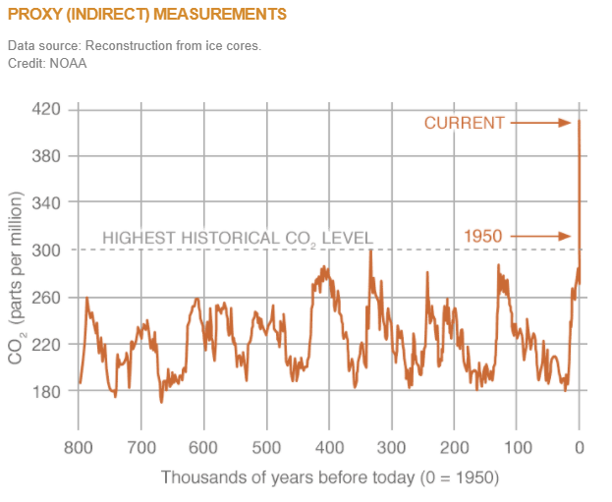
X: Thousand of years before today ( Years)
Y: CO₂ concentration (parts per million)

- What are the maximum and minimum concentrations of CO2 prior to the most recent rapid increase?

  - Maximum: 320 parts per million
  - Minimum: 180 parts per million

- Describe the variations you see, in terms of the period of the change and the magnitude of the change.

Concentration of CO₂ variations are changing over time, for the last 800 years, the atmospheric concentration of CO2 has been fluctuating, in some years, concentration would be high and in other times the concentration is low. However, since 1950, the pattern has been different such that the concentration of CO2 has been drastically increasing with time up to date.
As described in the video, these variations are driven by a combination of changes in the orbit of the earth affecting sunlight distribution on the globe through the year, and changes in CO2.

Compare the record of CO2 on the website to the graph below (from Lisiecki and Raymo - carefully note the different scales, including the time scale). The graph below shows the ratio of two isotopes of oxygen (¹⁸O/¹⁶O) measured on the CaCO3 from calcareous zooplankton (foraminifera) in the oceans (see https://earthobservatory.nasa.gov/features/Paleoclimatology_OxygenBalance). When the ratio is high (downward on the graph – note the y-axis scale), it indicates the presence of ice sheets and low sea level (as water moves from the oceans to the ice sheets), when the ratio is low it indicates warm conditions and high sea level (as the ice sheets melt away).

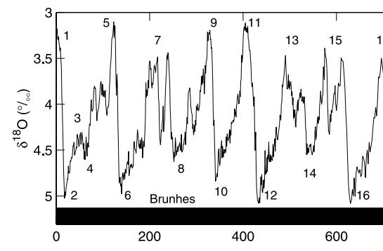

Thousand years ago

- About how often do interglacial conditions (warm, minimal ice sheets, high sea level) like today occur?

Interglacial conditions tend to occur during peak solar radiations periods/high temperatures, full interglacial conditions occur in about every fifth peak of the precession cycle.
- Describe the relationship between CO2 concentrations and the occurrence of interglacial versus glacial conditions. For example, when CO2 is HIGH we have which condition? When CO2 is LOW we have which condition? Compare the graph above to the one on the website!

During peak glacial conditions, the atmospheric concentration of CO₂ is about 150 $±$50 parts per million and during interglacial conditions, the atmospheric concentration of CO₂ is about 300 $±$50 parts per million. This shows that during glacial periods, the atmospheric concentration of CO₂ is lower than during interglacial periods.

Now scroll down and play the Time Series: 2002-2016 animation showing the global increase in CO2

Next go to the Global Temperature page (see the link below the photo at the top of the webpage), scroll down and play the Time Series: 1884 to 2018 showing the global temperature anomaly (relative to the average from 1951-1980) during this time period.

2002-2016 animation showing the global increase in CO2

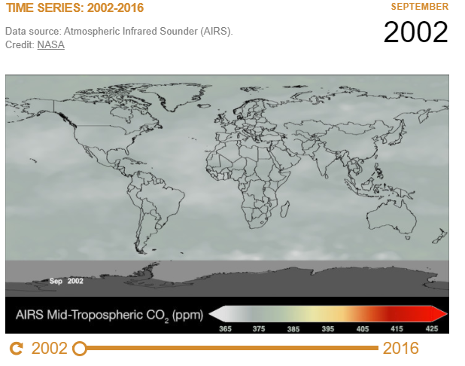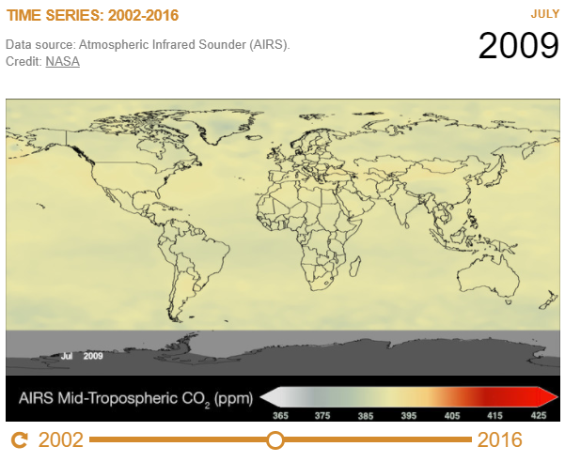
Changes in atmospheric concentrations of CO2 for 2002 and 2009

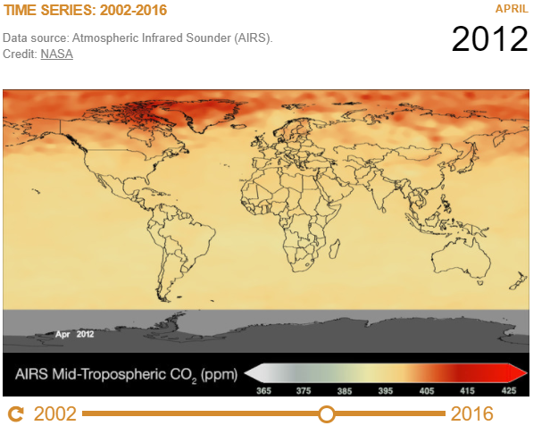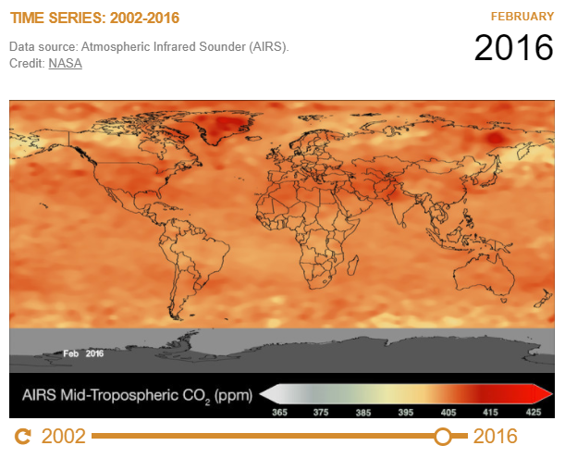
Changes in atmospheric concentrations of CO₂ for 2012 and 2016

1884 to 2019 showing the global temperature anomaly

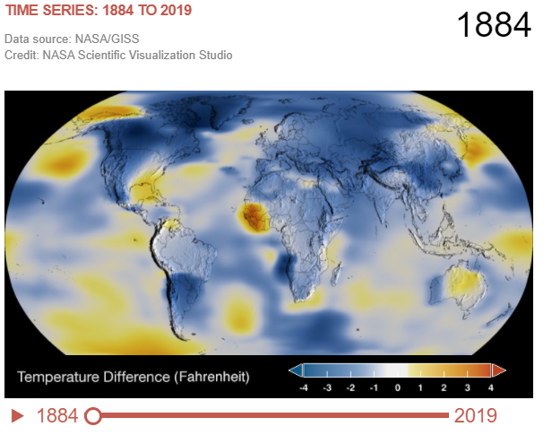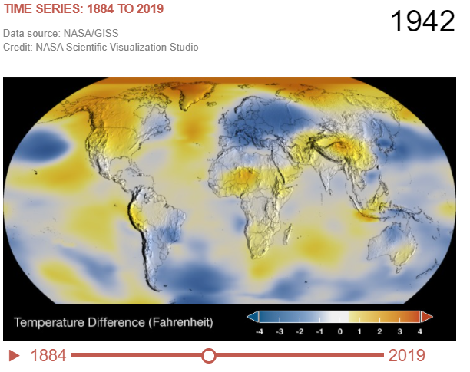
Changes in atmospheric temperature for 1884 and 1942
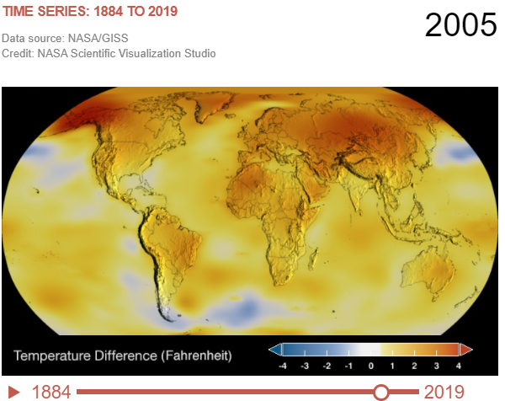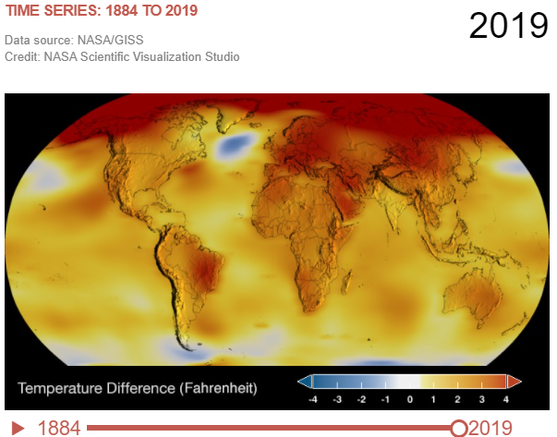
Changes in atmospheric temperature for 2005 and 2019

7. Describe the trend that is clear in both of these animations.

The trend for both atmospheric concentration of CO2 and temperature have a lot of similarities. CO2 concentration has been increasing with years. On comparing the atmospheric concentration of CO2 in the year 2002 and that of the year 2016, one can notice that the atmospheric concentration of CO2 has been increasing drastically with years.
Same thing applies with the atmospheric temperature, which has also been increasing with years. On comparing the atmospheric temperature in the year 1884 and that of 2019, one can notice that temperature has also been increasing drastically with years.

Scroll up to the Global Land-Ocean Temperature Index
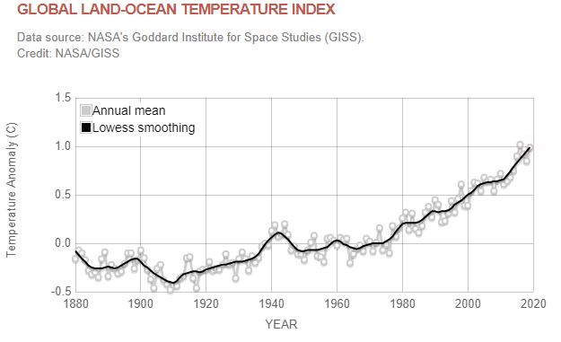
Global Land-Ocean Temperature Index

8. What is the average temperature anomaly now (relative the 1951-1980 average)?

The average temperature anomaly now relative to the 1951-1980 average is 0.99 °C/ 1.78 °F

Now go to the Sea Level webpage. Read the information given there.

- What two factors primarily cause sea-level rise?

The rise in sea level are caused majorly by factors related to global warming. The two primarily causing sea-level rise are: Melting of ice sheets and glaciers due to rise in temperatures resulting from global warming which increases water levels. The second factor is the expansion of seawater as a result of warming of oceans due to high thermal expansion caused by high temperatures resulting from global warming.

- What is the current rate of change based on the satellite data?
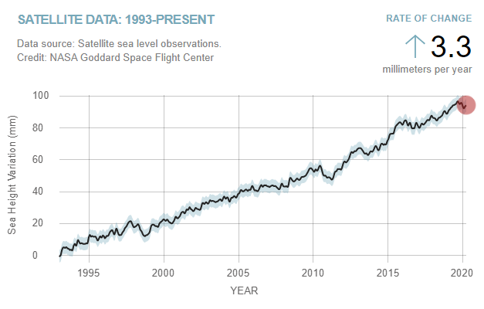
The current rate of change is 3.3 millimeters per year.

- Look at the Ground Data: 1870-2013 plot. These data are from tide gauges and go further back in time than the satellite data. Is sea level rising or falling through time? Is the change linear (equal amount of change every year) or accelerating (increased amount of change each year)?
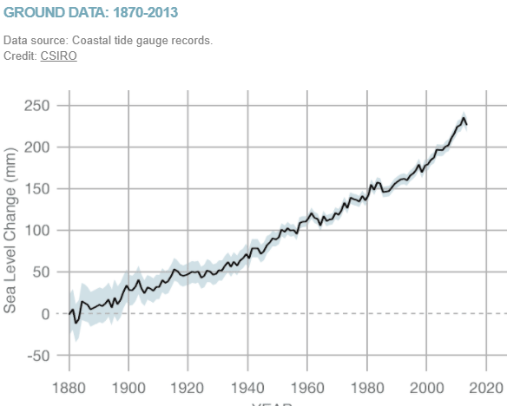

From ground data 1870-2013 plot, one can observe that the sea level has been rising through time, the sea level is lower in the past years and higher in the present years.
The change in sea level is accelerating since there is an increased amount of change every year.

Now go to the Ice Sheets page

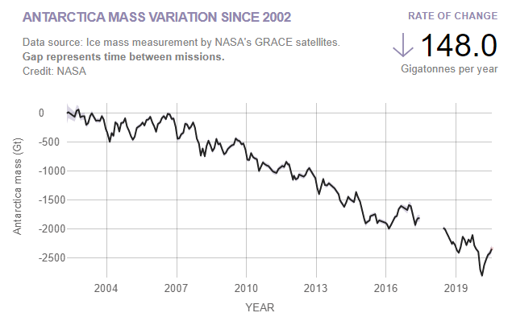
Antarctica mass variation since 2002
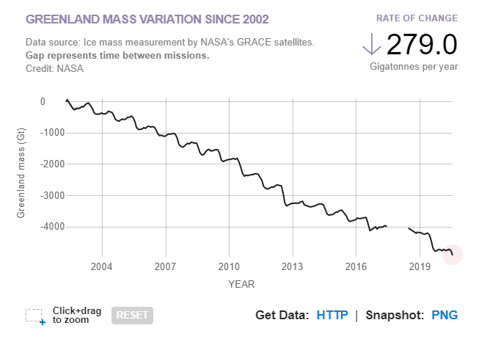
Greenland mass variation since 2002

- What data are shown on these two graphs?

The first graph shows Antarctica mass variation since 2002 of ice sheet against time in years.
The second graph shows Greenland mass variation since 2002 of ice sheet against time in years.

- What is a Gigaton in terms of kilograms?

1 Gigatonne is 1000 kilograms

- What is the current rate of change (ice loss) in the Antarctica and in Greenland?

148.0 Gigatonnes per year in Antarctica
279.0 Gigatonnes per year in Greenland

- What impact does that melting have on sea level?

Melting rises the sea level. When ice melts or glaciers melts, the water flow down into the oceans and sea hence rising the sea levels.
Finally, visit the Sea Ice page
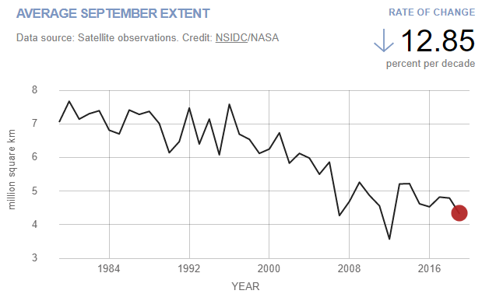

- Watch the Time Series animation. What is the rate of change in Arctic sea ice per decade?
The rate of change is 12.85 percent per decade.

Watch the brief video at: https://www.youtube.com/watch?v=3v9aRQpumPA

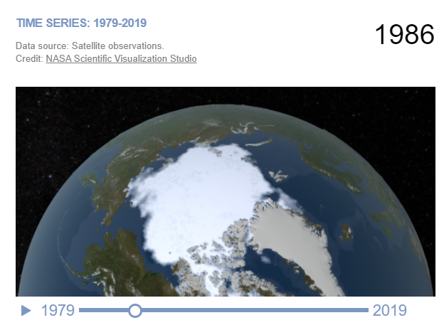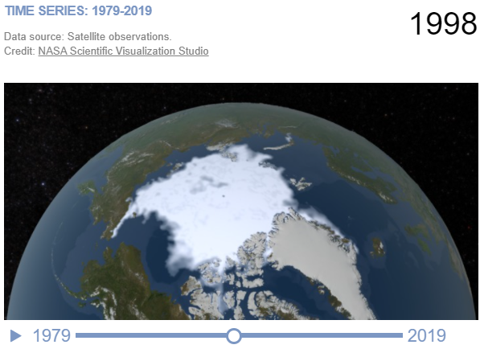
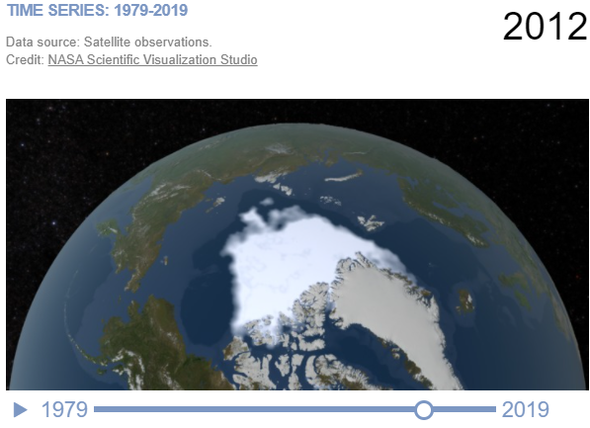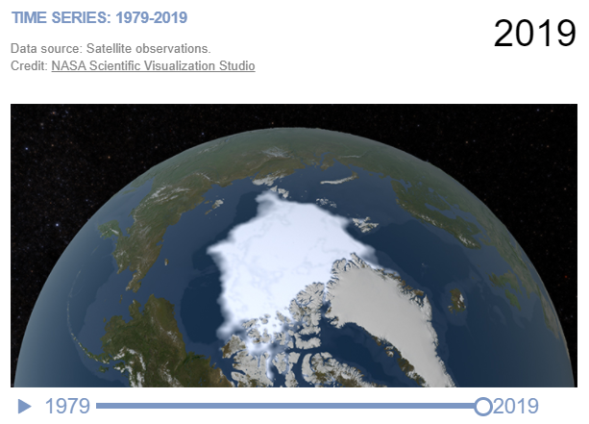

17. How does the computer model compare to the actual observations of sea ice?

The concentration of sea ice has been reducing through years especially from the 1990 which can be observed in Time Series animation. Time series animation presents a shrinking sea ice through years. Another observation that is similar to the computer model, is that during summer, around august to September, the sea ice shrinks the most it actually reduces to about 50 % of the original and then the size of sea ice increases during winter seasons.

- What does the computer model suggest about the future of sea ice in the Arctic?

The computer model predicts a great loss of sea ice during summer seasons in the Artic to an extend that by 2100, the Artic during summer seasons will be free of sea ice. It predicts that generally in the future, summer time ice cover will completely disappear in the Artic due to rise in temperatures causing ice melts through years especially during the summer seasons.

- What happens to the temperature of the ocean as sea-ice melts, and what effect does that have on further sea-ice melting?

Sea ice surfaces reflects sunlight while exposed seas absorbed 90% of the sunlight which rises the sea temperatures that in return melts more ice. When sea ice melts, it exposes the sea and there will be no more ice to reflect back the sunlight, what happens is, the exposed sea results in absorption of more sunlight and in return sea temperature rise, which melts more ice as well.

Two brief but interesting and informative videos can be found in the Canvas module and two more through the links below:

https://vimeo.com/41807260

https://climate.nasa.gov/climate_resources/101/video-global-temperature-variation/

